OTHER ICTSI WORK HIGHLIGHTS

In-House Global Legal of Filipino – Owned Multinational Company: Control and Monitoring

ICTSI is a Filipino – owned multi-national company. It is the parent company --- the headquarters. All the 32 terminals in 18 countries comply with its practices and policies. The Global Legal supports ICTSI in controlling and monitoring various legal and compliance matters.

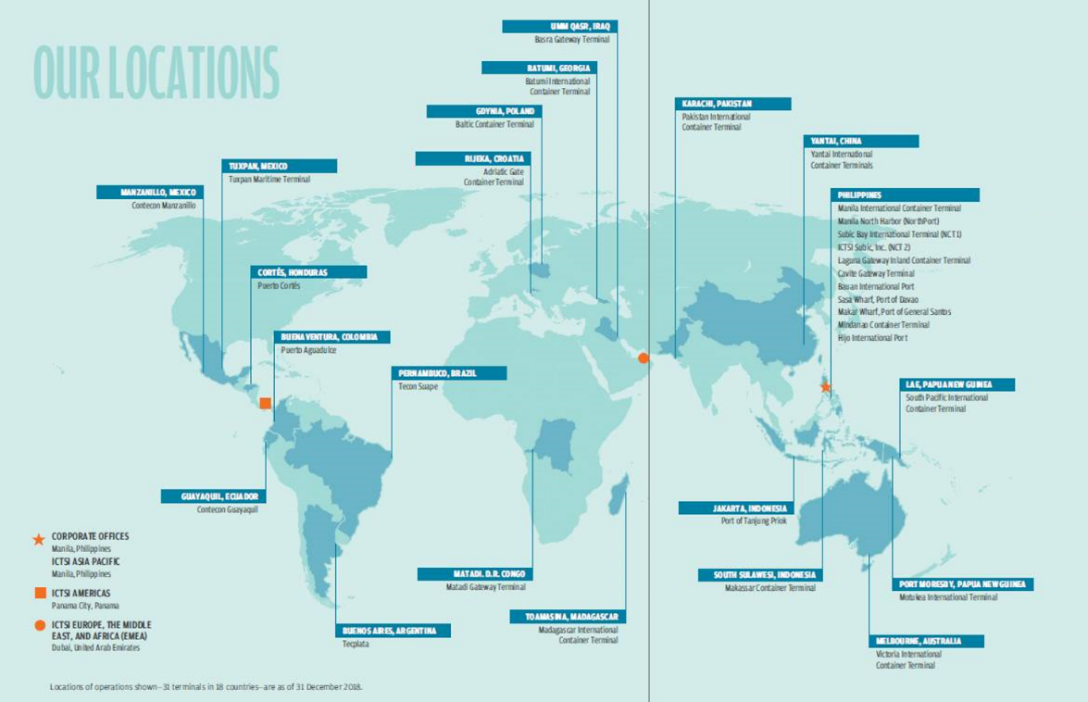

The Global Legal controls these terminals practices and policies in relation to mitigation of legal risks and compliance. One way of achieving this is through ICTSI’s suite of standard documents being used in its dealings with its customers and users of its container terminals consists of the Standard Trading Conditions (STCs) and Terminal Services Agreement (TSAs). STCs are used with customers and other users of the container terminals. On the other hand, the TSAs are short form agreements and incorporate ICTSI's STCs (and are used only with shipping lines. The Global Legal reviewed, revised and rolled – out ICTSI’s STCs and TSAs to all operating terminals. The STCs and TSAs are in place to allocate the risks between the terminal operator and the port user as well as to clearly define each party’s rights and obligations. These have been very useful when there are claims by either party. Since no two terminals are the same, there are updates and revisions on the STCs and TSAs and these are submitted to the Global Legal in Manila being the “in-house global Global Legal” for review and vetting.

Global Legal likewise controls the corporate housekeeping of the ICTSI holding companies and those of newly acquired operating companies. The ICTSI parent company control over the terminals are done through board resolutions of the holding companies which own and control the terminals. Board resolutions and other corporate documents relating to the ICTSI holding companies are either drafted by Global Legal or drafted in collaboration with external counsels in jurisdictions wherein there are specific legal requirements which need to be complied. For newer terminals, such as Lae and Motukea ports in Papua New Guinea, Global Legal drafts the necessary corporate housekeeping requirements of these ports and even reviews the material contracts in the terminals.

Global Legal is likewise in charge of actively monitoring and maintaining terminal databases. This task includes ensuring all concession agreements and concession related obligations are complied with and to flag the terminals if there is a need to start any negotiations pertaining to the extension of the concession agreements.

Finally, Global Legal monitors the terminals’ sustainability efforts in order to properly document them in ICTSI’s sustainability report.

Global Legal is a driving force which ensures ICTSI’s control and monitoring of its various terminals.

Empowering Labor: Working Together and Working Smarter

The most important and valuable asset of any organization is its human resource. The Global Legal ensures faithful compliance to the provisions of the CBA and company policies and laws on labor standards and occupational health and safety. ICTSI puts value on it manpower and considers them as not mere implements of production but actual stakeholders of the business. ICTSI ensures that it looks after the welfare of its employees by providing them the needed trainings for knowledge and skills enhancement. Aside from employee trainings, ICTSI also puts premium in the well-being of employees by providing them with adequate and necessary health and welfare benefits. Offering convenient access to health care services will not only promote health awareness but will likewise reduce lost productivity. Moreover, proactively supporting the health needs of employees will reduce absenteeism, improve productivity and increase employee engagement. Maintaining a happy and contented workforce shall translate to harmonious industrial relations.

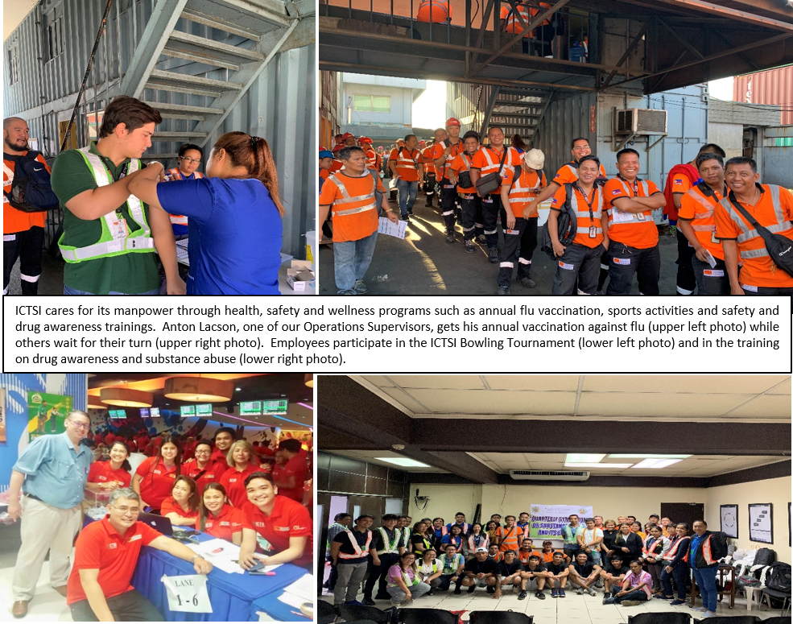

Nevertheless, the thrust now is not merely limited to maintenance of industrial peace in the workplace. Through efforts spearheaded by the Global Legal, there is a transition towards labor empowerment by working together through cooperative partnership at work and working smarter by determining root causes of issues with focus on quality development in person, in work relations and in services provided. Participatory development is given much importance in order to develop an ideal situation where both management and workers act as full partners in identifying problems at the workplace, crafting solutions to these problems and implementing the agreed-upon solutions.

Through participatory development, workers are afforded the chance to contribute to the improvement of present processes, development of talent and the advancement of employees’ health, safety and welfare. ICTSI recognizes that employee participation is a crucial component of workplace empowerment. It adds dynamism to the employer-employee relationship by giving workers not only a voice in decision-making on matters that affect their interest and welfare but also an opportunity to contribute creative and innovative ideas to achieve enhanced service quality and productivity. This workplace cooperation mechanism has brought about success in arriving at solutions to problems of mutual concern as well as in collective bargaining negotiations where ICTSI and the union recently concluded a new five year CBA after only a record breaking nine hours of peaceful and fruitful negotiations.

