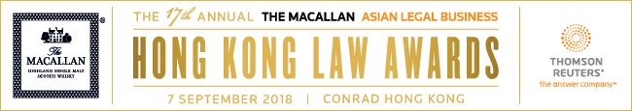

SUBMISSION FORM – FIRM CATEGORIES (II)

Read the Research Methodology Summary before filling out the submission form.

Deadline for submissions – 12 July 2018 (Thursday)
Submit the completed forms to mary.aquino@thomsonreuters.com.

For The Macallan Highland Single Malt Scotch Whisky Award Hong Kong Law Firm of the Year,
please use Submission Form - Firm Category (III).

For all the other firm categories, please use Submission Form - Firm Categories (I).

This form is for one category only. To submit for another category, please complete a new form.
Save this form using the format: Category_Organisation.

DEAL FIRM OF THE YEAR
Law firm
A. BASIC INFORMATION
Residence (Please indicate “Hong Kong” to confirm that the candidate is based therein.)
Practice team size
No. of deals completed between
1 May 2017 and 30 April 2018
Vol. of deals completed between
1 May 2017 and 30 April 2018
(in USD)
B. KEY WORK HIGHLIGHTS
KEY WORK NO. 1: (Indicate heading here)
Completion date:
Deal size in USD:
Description (max. of 500 words)

KEY WORK NO. 2: (Indicate heading here)
Completion date:
Deal size in USD:
Description (max. of 500 words)

KEY WORK NO. 3: (Indicate heading here)
Completion date:
Deal size in USD:
Description (max. of 500 words)

KEY WORK NO. 4: (Indicate heading here)
Completion date:
Deal size in USD:
Description (max. of 500 words)

KEY WORK NO. 5: (Indicate heading here)
Completion date:
Deal size in USD:
Description (max. of 500 words)

C. OTHER ACHIEVEMENTS (max. of 300 words)

