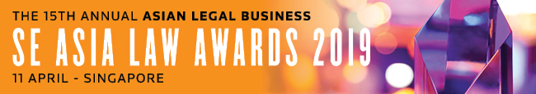

SUBMISSION FORM – FIRM CATEGORIES (II)

Read the Research Methodology Summary before filling out the submission form.

Deadline for submissions – 18 January 2019 (Friday)
Send the completed forms to mary.aquino@thomsonreuters.com.

For SE Asia Law Firm of the Year, please use Submission Form - Firm Category (III).

For all the other firm categories, please use Submission Form - Firm Categories (I).

Save this form using the format: Category_Organisation.
CHOOSE A CATEGORY HERE
Law firm
A. BASIC INFORMATION
Country of residence (to confirm that the nominee is based in SE Asia)
Head of practice (if relevant)
Practice team size (if relevant)
No. of deals completed in 2018
Vol. of deals in 2018
(in USD)
B. KEY WORK HIGHLIGHTS
KEY WORK NO. 1: (Indicate heading here)
Completion date:
Deal size in USD:
Description (max. of 500 words)

KEY WORK NO. 2: (Indicate heading here)
Completion date:
Deal size in USD:
Description (max. of 500 words)

KEY WORK NO. 3: (Indicate heading here)
Completion date:
Deal size in USD:
Description (max. of 500 words)

KEY WORK NO. 4: (Indicate heading here)
Completion date:
Deal size in USD:
Description (max. of 500 words)

KEY WORK NO. 5: (Indicate heading here)
Completion date:
Deal size in USD:
Description (max. of 500 words)

C. OTHER ACHIEVEMENTS OF NOMINEE
Description (max. of 500 words)

