ALB is pleased to announce our Asia's Top 15 M&A Lawyers 2023 to be released in the ALB Asia Magazine's May 2023 issue is now open for submission. The ranking celebrates top M&A lawyers who demonstrate practical experience and drive the deal-making to the next phase of success, not only in terms of the deal value but also in the impacts it creates.

Profile of deals handled, clients’ recommendations, and the use of technology to spearhead the deal- making will be considered when making the assessment.

We look forward to receiving your submission soon.

HOW IT WORKS

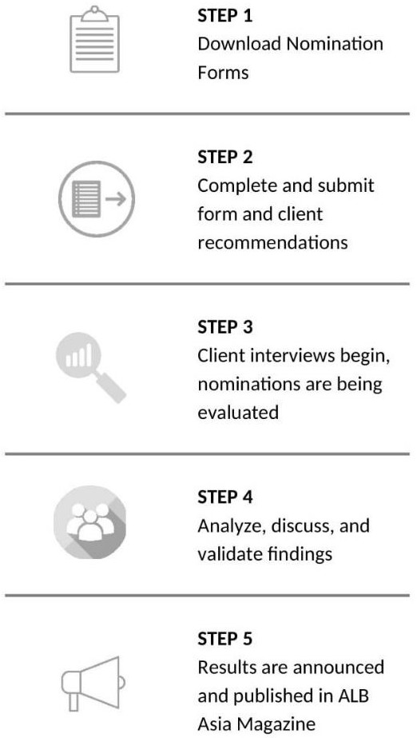How can you submit the nomination form?
The completed nomination form may be submitted by law firms or lawyers. It provides a summary of your M&A achievements. It also presents an opportunity to demonstrate why you should be ranked in our ALB Asia’s Top 15 M&A Lawyers 2023.

You may download the nomination form here. It will guide you through all the relevant information required for our research and the information provided will be kept completely confidential, if indicated.

Who can submit and when?
Submissions are open to any practicing M&A lawyer. One firm can nominate up to TWO (2) lawyers who:
- Be permanently based and practice law in Asia.
- Have outstanding achievements in M&A deal(s) either taking place in Asia or representing an Asian client overseas from 16 December 2021 to 16 December 2022.
- Submissions from Mainland China and Australia/New Zealand will not be considered for this list.

Submission Deadline is Monday, 20 February 2023, 6.00pm (Singapore Time)

Our deadlines are fixed in order to allow enough time for our research team to conduct thorough verifications, retrieve recommendations, and implement careful analysis on each submission

How to make a submission
Simply provide a clear summary of the following in our nomination form:

- The 5 most important M&A deals* in your career and in the last 12 months (from 16 December 2021 to 16 December 2022).
- Provide a list of any significant accolades you have received from work.

* Deals that have been announced but are pending completion during the evaluation period may still be submitted for consideration.

Providing client recommendations
We also require a list of referees, whom we may interview. A referee is usually a client, although it can be anyone who has experience and knowledge of your firm in that practice area over the preceding 12 months. Providing referees allows us to gather feedback on your practice. We use these interviews to understand the views and experiences of your clients and this helps to inform our decisions.

Research
We conduct our ranking research based on several factors and considerations, all of which are assessed by our research team. Our dedicated research team will review all submissions provided and carry out the necessary interviews.

Sending across your nominations and being interviewed by ALB does not guarantee a ranking. This is only part of the research process. We also consider feedback of clients and other sources as part of the ranking process.

Online Research
  - Verify the candidate’s profile via firm’s website
  - Investigate and assess the significant M&A deal submitted by the candidate
  - Review and analyze the deals which lawyers participated in the last 12 months which are available on public channels

Interview
Interview with clients and peers listed in the submission. This is usually done to assess client satisfaction and reputation in the industry

Details in 1 and 2 will be compiled and moved to the evaluation process.

Evaluation Process
After research and the verification of facts in the nomination forms, all documents will be sent to an independent internal judging panel for evaluation.

Evaluation Criteria
- Significant deals handled in entire career
- Significant deals handled in the last 12 months (from 16 December 2021 to 16 December 2022)
- Key clients and new clients
- Significant accolades / third-party award or recognition
- Client recommendations and comments
- Comments from managing partner or colleague The deals evaluation is based on the following factors:
- Magnitude (Deal-size): The value of each deal-size, calculated in USD.
- Complexity and Breadth: The degree to which the work required the crucial exercise of legal expertise, or business acumen. The breadth means the degree to which the work involved numerous jurisdictions, parties, and industries.

- Diversity of M&A Experience: The diverse natures/categories across the deals that you have represented. For example, major takeover, public M&A, privatization, major spin-off, VC fundraisings, JV establishment, etc.

- Impact: The importance and impact of the deal to the industry players.

- Clients’ Experience: Clients’ recommendations about the candidate will be reviewed.

- Sustainable Values: The degree to which the deals considered the environmental, social and governance (ESG) factors or to create long-term sustainable values.

- Innovativeness: The degree to which the work involved applying creative solutions during the deals. It can include using technology, or analytics to uncover opportunities and risks in each deal.

Announcement
ALB Asia’s Top 15 M&A Lawyers results will be released in the May 2023 issue of ALB Asia Magazine.

