ALB is pleased to launch our ALB Asia's Top 15 ESG Law Firms, which will be announced in ALB Asia magazine's March 2023 edition. This list will spotlight the law firms that have delivered exceptional legal services for the businesses in addressing ESG considerations while achieving long-term prosperity.

We are now accepting submissions for ALB Asia’s Top 15 ESG Law Firms until Friday, 23 December 2022; 6:00pm (Singapore time).

Please note that submission does not guarantee a place on the list, and law firms need to be based in Asia for at least the past 12 months to qualify. Submissions from mainland China and Australia/New Zealand will not be considered for this list.

Past and existing achievements as well as profile of deals/matters handled, clients’ recommendations, and any significant accolades and awards received will be taken into consideration when making the assessment.
Submissions are opened from 22 November 2022 to 23 December 2022.

We look forward to receiving your submission soon.

HOW IT WORKS

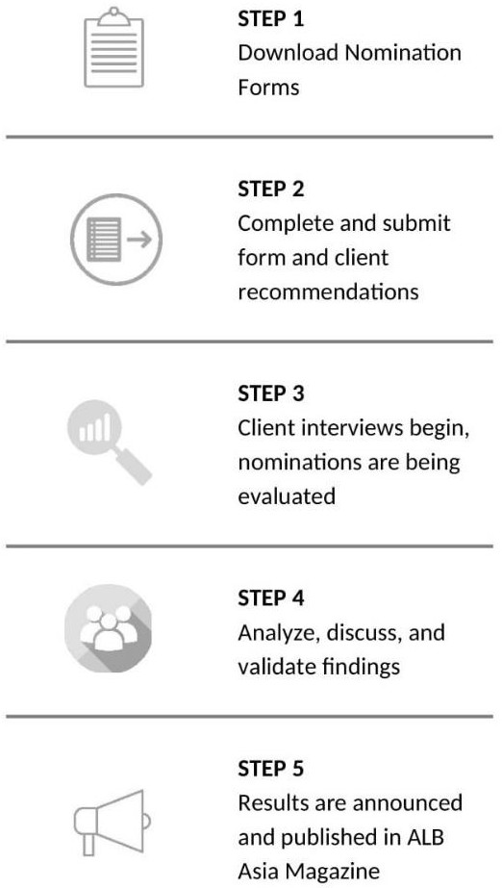
How you can submit the nomination form
The completed nomination form may be submitted by law firms or lawyers. It provides a summary of your overall achievements. It also presents an opportunity to demonstrate why you should be ranked in our ALB Asia’s Top 15 ESG Law Firms.

You may download the nomination form here. It will guide you through all the relevant information required for our research. The information provided will be kept completely confidential.

Who can submit and when
- Law firms need to be based in Asia for at least the past 12 months to qualify
- Submissions from Mainland China and Australia /New Zealand will not be considered for this list

Submission deadline Friday, 23 December 2022, 6.00pm (Singapore Time)

Our deadlines are fixed in order to allow enough time for our research team to conduct thorough verifications, retrieve recommendations, and implement careful analysis on each submission

How to make a submission
Simply provide a clear summary of the following in our nomination form:

- Top 5 most significant achievements (ESG-related) of the firm.
- Top 5 most significant ESG-related work handled in the last 18 months.
- List of firm’s key clients on ESG-related matters.
- List of new clients wins on ESG-related matters in the past 18 months.
- Significant accolades the firm has received for ESG-related practices in the form of public recognition, awards etc.

Providing client recommendations
We also require a list of referees, whom we may interview. A referee is usually a client, although it can be anyone who has experience and knowledge of your expertise over the preceding 18 months. Providing referees allows us to gather feedback on your practice. We use these interviews to understand the views and experiences of your clients, and this helps to inform our decisions.

Clients’ statements are referred to in the first instance and referees are only contacted should ALB require additional information regarding the matters included in the submission.

Research
We conduct our ranking research based on several factors and considerations, all of which are assessed by our research team. Our dedicated research team will review all submissions provided and carry out the necessary interviews.

Sending across your nominations and being interviewed by ALB does not guarantee a ranking. This is only part of the research process. We also consider feedback of clients and other sources as part of the ranking process.

Online Research
  - Verify the firm’s profile through public channels

  - Investigate and assess significant achievements, deals and matters submitted
  - Review and analyze the ESG-related work that the firm handled in the last 18 months and are available on public channels

Interview
Interview with clients listed in the submission. This is usually done to assess clients
satisfaction and reputation in the industry if necessary

Details in 1 and 2 will be compiled and moved to the evaluation process.

Evaluation Process
After research and the verification of facts in the nomination forms, all documents will be sent to an independent internal judging panel for evaluation.

Evaluation Criteria
- Significant ESG-related work handled by the firm since establishment
- Significant ESG-related work handled in the last 18 months
- Clients that the firm has advised for
- New clients win in the last 18 months
- Significant accolades / third-party award or recognition
- Client recommendations and comments

The evaluation is based on the following factors:
- Complexity: the degree to which the work required the crucial exercise of ESG-related practice.
- Breadth: the breadth means the degree to which the work involved numerous jurisdictions, legal practice areas, parties and industries.
- Significance: the degree to which industry players or the region may be affected by the ESG-related work.

Announcement
ALB Asia’s Top 15 ESG Law Firms will be release in March 2023 issue of ALB Asia Magazine.

