ALB is pleased to launch our ALB Asia's Top 15 Intellectual Property (IP) Lawyers Ranking which will be announced in ALB Asia magazine's December 2023 edition. This list will highlight the achievements of the top 15 IP lawyers across Asia who have consistently delivered high-quality IP work, set high standards in the IP space, while earning accolades from their colleagues, superiors and clients.

We are now accepting submissions for ALB Asia’s Top 15 IP Lawyers until Monday, 11 September 2023; 6:00pm (Singapore time).

Please note that submission does not guarantee a place on the list, and lawyers need to be based in Asia for at least the past 12 months to qualify. Submissions from mainland China and Australia/New Zealand will not be considered for this list.

Past and existing achievements as well as profile of matters/cases handled, clients’ recommendations, and any significant accolades and awards received will be taken into consideration when making the assessment.
Submissions are opened from 12 June 2023 to 11 September 2023.

We look forward to receiving your submission soon.

HOW IT WORKS

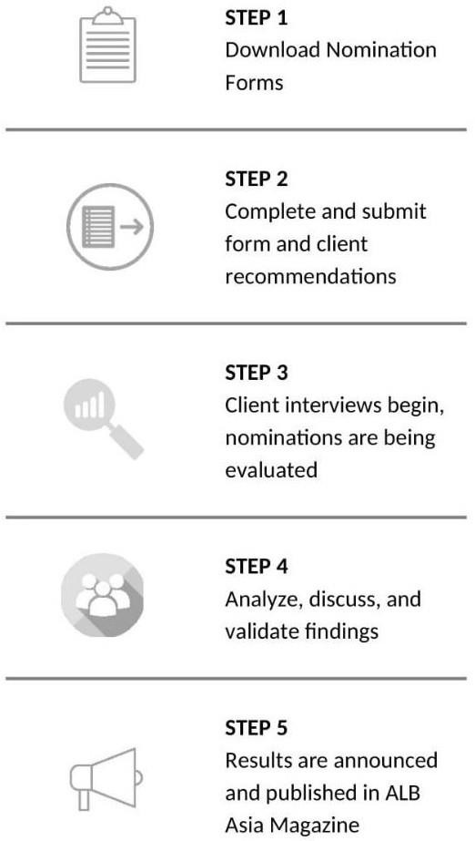
How you can submit the nomination form

The completed nomination form may be submitted by law firms or lawyers. It provides a summary of your overall achievements. It also presents an opportunity to demonstrate why you should be ranked in our ALB Asia’s Top 15 IP Lawyers.

You may download the nomination form here. It will guide you through all the relevant information required for our research. The information provided will be kept completely confidential.

Who can submit and when
Submissions are open to any practicing IP lawyer. One firm can nominate up to TWO (2) lawyers.

Submission Conditions:

- Lawyers need to be based in Asia for at least the past 12 months to qualify
- Submissions from Mainland China and Australia/New Zealand will not be considered for this list

Submission deadline Monday, 11 September 2023, 6.00pm (Singapore Time)

Our deadlines are fixed in order to allow enough time for our research team to conduct thorough verifications, retrieve recommendations, and implement careful analysis on each submission

How to make a submission
Simply provide a clear summary of the following in our nomination form:

- Top 5 most significant achievements (IP matters, cases etc.) in candidate’s career.
- Top 5 most significant IP work handled in the last 12 months.
- Up to 5 of candidate’s key clients.
- Up to 5 new clients wins in the past 12 months.
- Significant accolades the candidate has received for IP work in the form of public recognition, awards etc.
- Support provided to help your firm or client thrive during the pandemic

Providing client recommendations
We also require a list of referees, whom we may interview. A referee is usually a client, although it can be anyone who has experience and knowledge of your expertise over the preceding 12 months. Providing referees allows us to gather feedback on your practice. We use these interviews to understand the views and experiences of your clients and this helps to inform our decisions.

Clients’ statements are referred to in the first instance and referees are only contacted should ALB require additional information regarding the matters included in the submission.

Research
We conduct our ranking research based on several factors and considerations, all of which are assessed by our research team. Our dedicated research team will review all submissions provided and carry out the necessary interviews.

Sending across your nominations and being interviewed by ALB does not guarantee a ranking. This is only part of the research process. We also consider feedback of clients and other sources as part of the ranking process.

Online Research
  - Verify the candidate’s profile via firm’s website

  - Investigate and assess significant achievements, matters and cases submitted by the candidate
  - Review and analyze the IP matters which lawyers participated in and for cases which judgements were pronounced in the last 12 months and are available on public channels

Interview
Interview with clients and peers listed in the submission. This is usually done to assess client satisfaction and reputation in the industry if necessary

Details in 1 and 2 will be compiled and moved to the evaluation process.

Evaluation Process
After research and the verification of facts in the nomination forms, all documents will be sent to an independent internal judging panel for evaluation.

Evaluation Criteria
- Significant achievements (IP cases and matters) throughout candidate’s career
- Significant IP work handled in the last 12 months
- Key IP clients
- New IP clients
- Significant accolades / third-party award or recognition
- Client recommendations and comments
- Comments from managing partner or colleague The evaluation is based on the following factors:
- Complexity: the degree to which the work required the crucial exercise of IP expertise, business acumen, or the development of innovative solutions.
- Breadth: the breadth means the degree to which the work involved numerous jurisdictions, legal practice areas, parties and industries.
- Significance: the degree to which industry players or the region may be affected by the IP work;
- Innovativeness: the degree to which the work involved applying new and/or creative. solutions to existing systems and processes to mitigate the impacts of Covid-19 pandemic or to transform the organizational capabilities. It can also include using technology, or analytics to uncover opportunities and risks in

Announcement
ALB Asia’s Top 15 IP Lawyers results will be release in December 2023 issue of ALB Asia Magazine.

